Area of triangle:

55

?

66°

13cm

e.g. Area13]2 ─ [ ½ 13 13 cos66]

=97.3370123837cm2─34.3692463399cm2

=62.9677660438cm2

=62.97 cm2

Area of Segment πr2)─ ( ½ x r x r x cosθ)

Area of segment= Area of sector – Area of triangle 2r2

Area of Segment:

e.g. Area= ½ x 15 x 15 x cos55

=64.5273490895

15cm

15cm

Area of triangle: ½ x b x c x cosA

Length of Arc:

e.g. π62

=113.097335529cm2

= 113.097…

=25.1327412287cm2

=25.13cm2

6cm

80

e.g. 2π10

=31.41…cm

= $\frac{60}{360}×$ 31.41..

=5.2359877559cm

=5.23cm

10cm

Area of Sector= $={\frac{θ}{360}×Area of the Circle}$

Area of Sector:

C= 40cm

60

Length= $={\frac{θ}{360}×Circumference of circle}$

Circles:

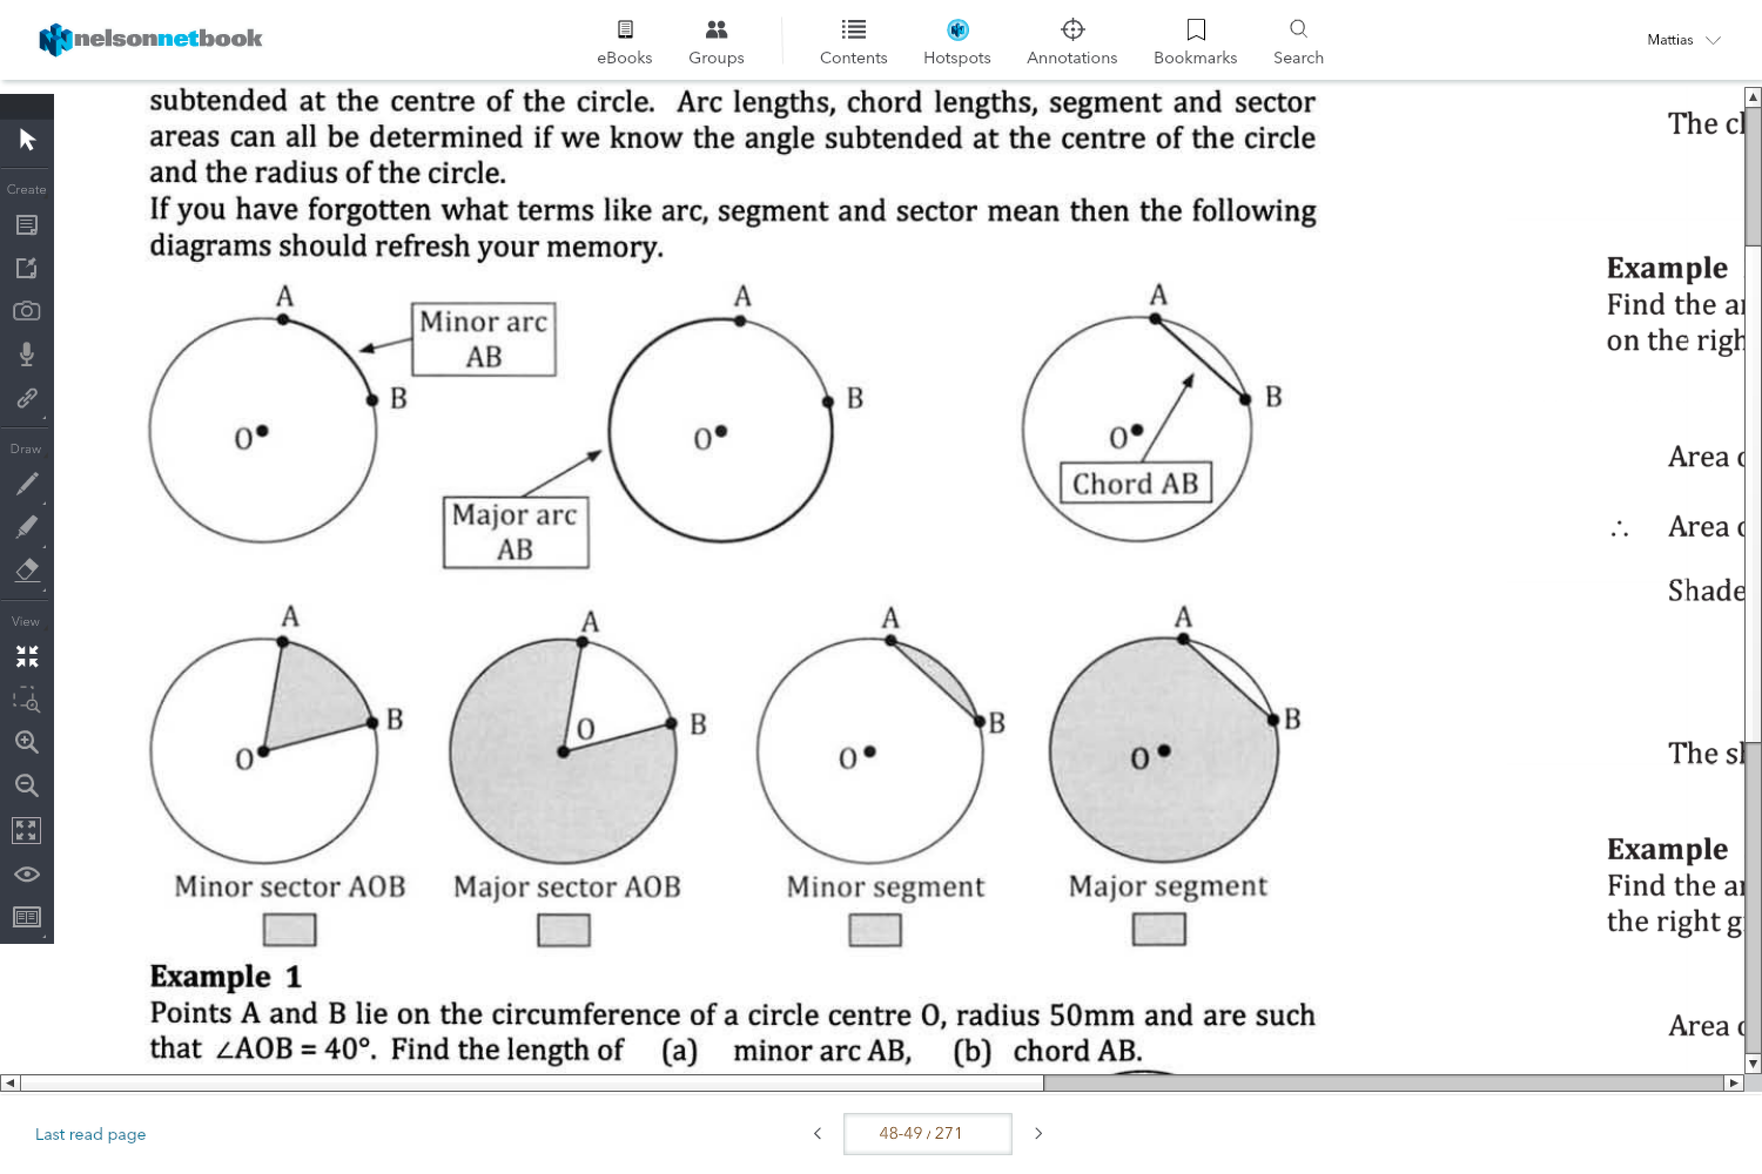

Area:

Area of a circle: πr2

e.g. π302

=2827.433…cm2

30cm

12cm

e.g. 2π12

=75.398…cm

Circumference= 2πr

Circumference: